**PrivateStoreServicesHTTPInterface war module deployment steps**

Copy c9t27229.itcs.hpicorp.net:/opt/apps/PrivateStore/ PrivateStoreServicesHTTPInterface.war to Primary server tmp folder

Select WCS application and click on update

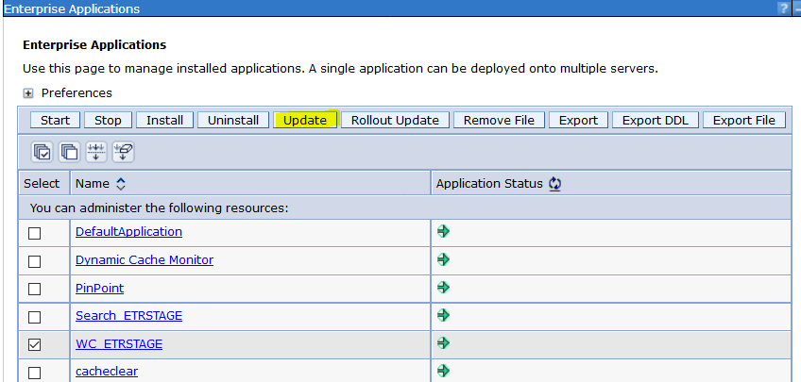

Select Replace or add a single module and select war file path from server

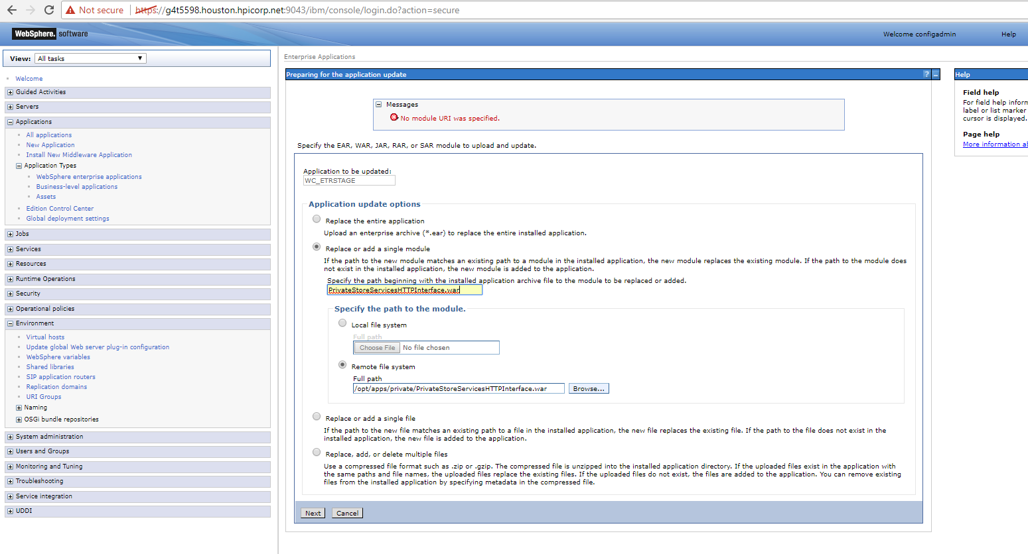

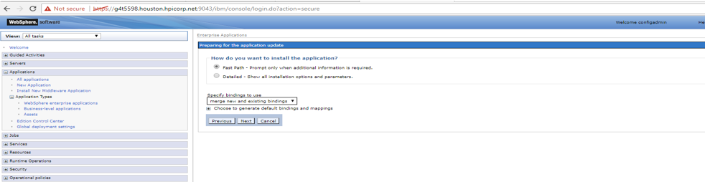

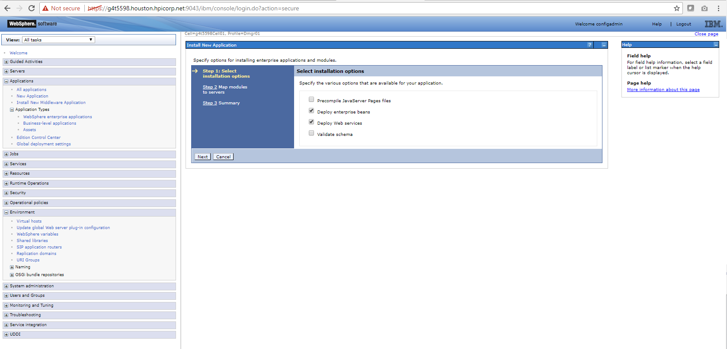

Here select only WCS web servers and Commerce cluster and select all check boxes click on apply.

Again select all check boxes click on next

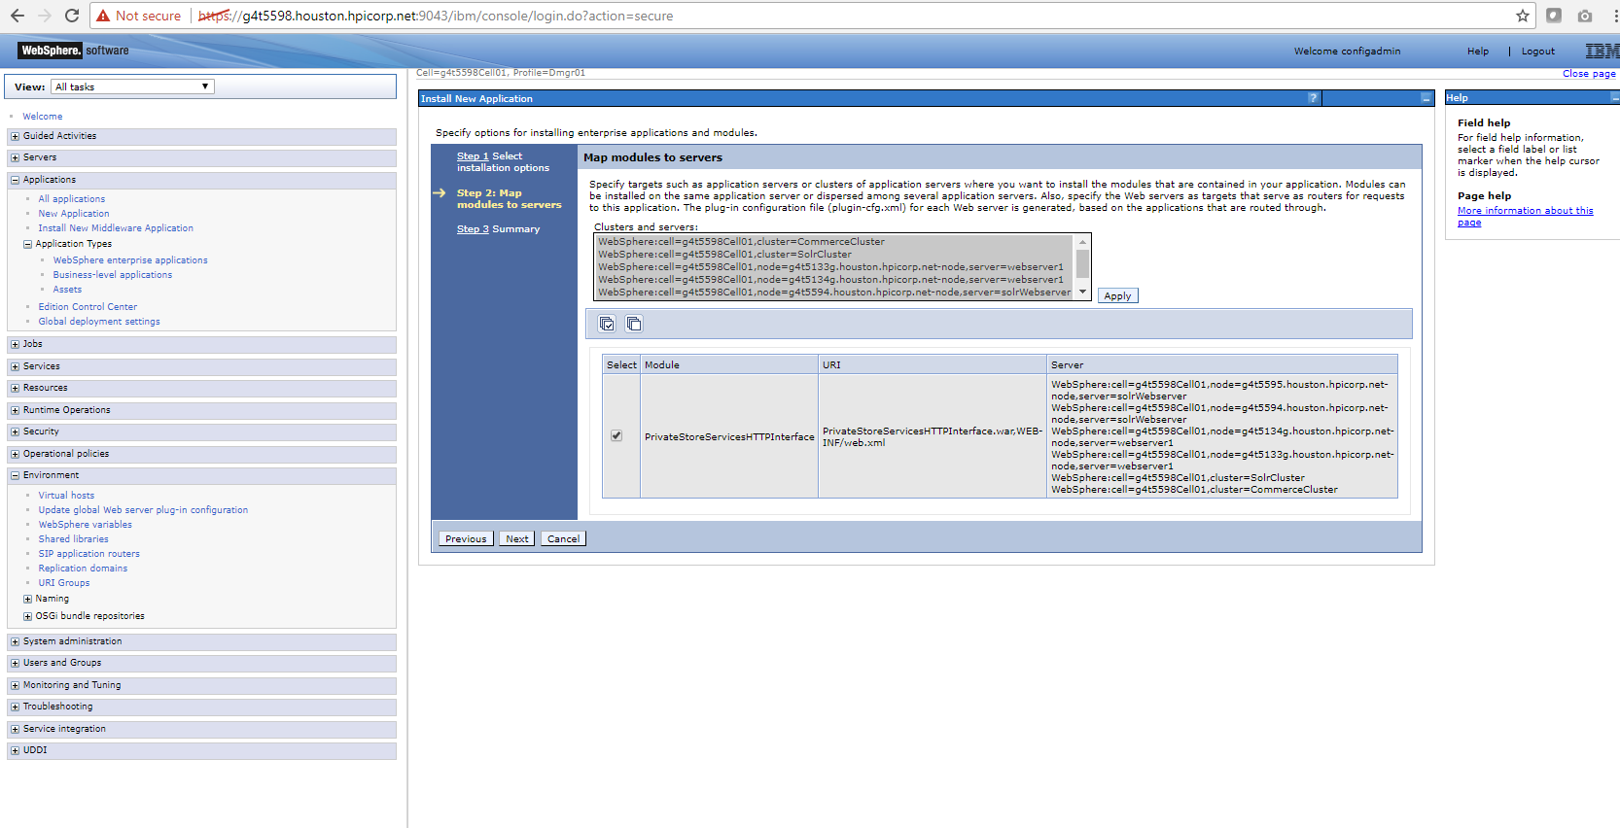

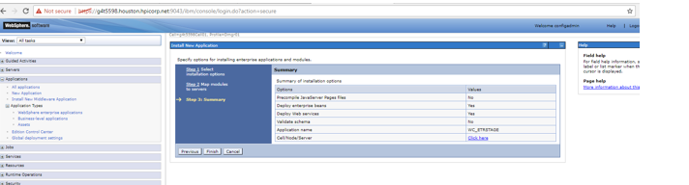

Review and save your changes.

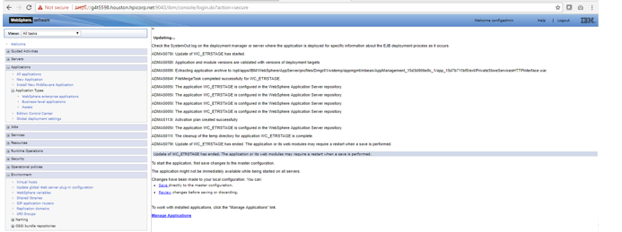

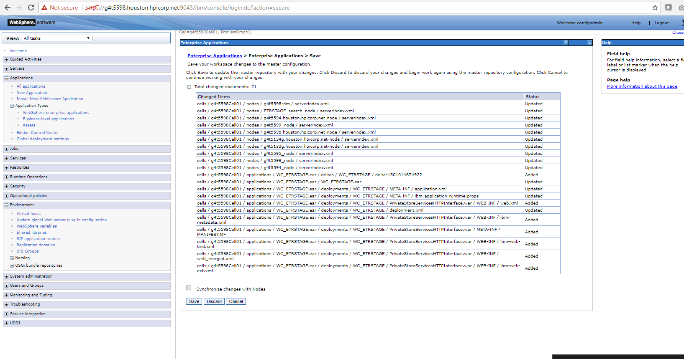

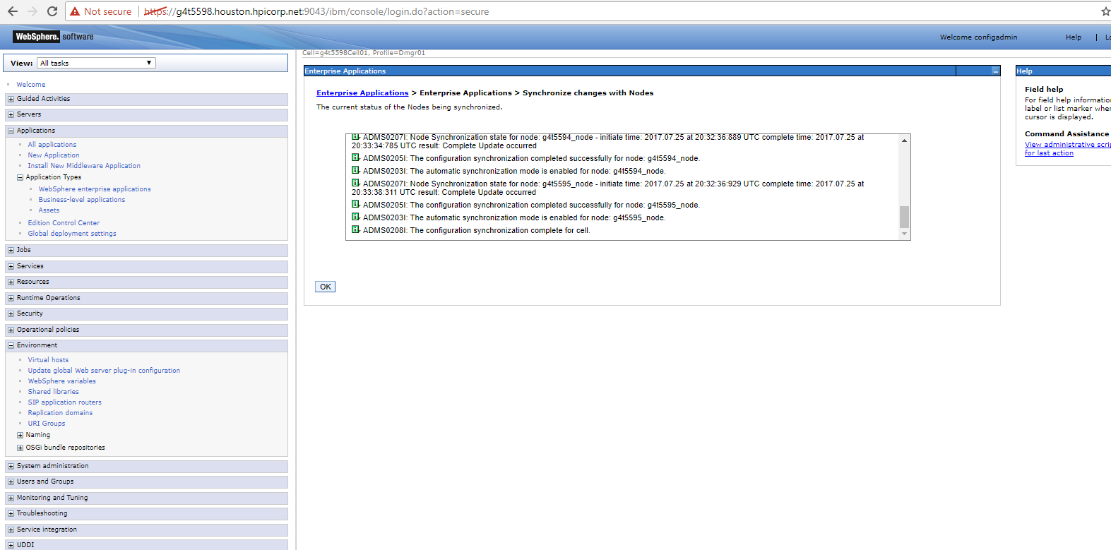

**Verification:**

Once application update completed and restarted go to app server and check /opt/apps/IBM/WebSphere/AppServer/profiles/ETRLIVE/installedApps/WC_ETRLIVE_cell/WC_ETRLIVE.ear/META-INF/ application.xml, it should have below entry.

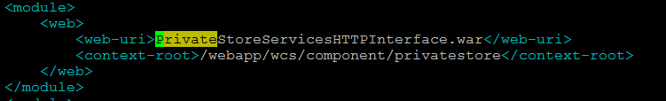

Once verified please proceed with usual WCS deployment.

**Post Whole WCS, Search deployment check Private Store deployment files availability in server using below.**

1. **Under /opt/apps/IBM/WebSphere/AppServer/profiles/ETRLIVE/installedApps/WC_ETRLIVE_cell/WC_ETRLIVE.ear/**

• PrivateStoreServicesHTTPInterface.war - Web module

• PrivateStore-Server.jar – EJB module

Check /opt/apps/IBM/WebSphere/AppServer/profiles/ETRLIVE/installedApps/WC_ETRLIVE_cell/WC_ETRLIVE.ear/META-INF/ application.xml, it should have below entry.

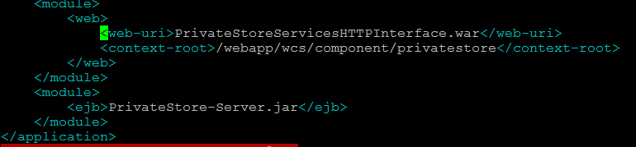

**Under /opt/apps/IBM/WebSphere/AppServer/profiles/ETRLIVE/installedApps/WC_ETRLIVE_cell/WC_ETRLIVE.ear/lib**

• PrivateStore-Client.jar - java module

• PrivateStore-DataObjects.jar – java module